

**TOURISM IN EAST JAVA AND ITS PROBLEM**

**Hardhita Kusdharyanto. S.ST.,Par.,M.Par**

Perhotelan,Pariwisata and Tourism, Politeknik NSC Surabaya,

hardhita77@gmail.com

**ABSTRACT**

These studies present a comprehensive study of the potential, development, and impact of the tourism sector in several regions in Indonesia, especially in Central Java and East Java Provinces. By applying various analytical methods such as Klassen Typology, Location Quotient, Shift Share, Ordinary Least Square, and Waterfall approach in the development of Geographic Information System (GIS), these studies succeeded in identifying the typology of tourism potential, base sectors and leading sectors that contribute to regional economic growth. The results show that tourism development not only increases Gross Regional Domestic Product through investment in hotels, an increase in the number of tourists (both domestic and foreign), and the length of stay of tourists, but also significantly increases employment in the hospitality sector. In addition, regional tourism development strategies, including promotional efforts and infrastructure optimization as well as the use of information technology for mapping, are key factors in improving competitiveness and empowering local entrepreneurs. Overall, the findings underscore the need for synergy between the government, industry players, and the application of technological innovation to support sustainable tourism development and positively impact regional economic development.

**Keyword** : Artificial Tourism, Tourism Development, Tourism Potential, Tourism Economy, Cultural Tourism.

1. **INTRODUCTION**

In the introduction, these studies highlight the strategic role of the tourism sector as a key driver of regional economic growth. It is explained that tourism not only serves as a means of recreation, but also a source of income, job creation, and a medium to introduce local culture. Each region has diverse tourism potential, ranging from natural, artificial, marine, religious, to health and cultural tourism, which if managed optimally can improve community welfare and encourage equitable development. Local governments are expected to play an important role through directed planning, effective promotion, and provision of supporting infrastructure to optimize this potential. In addition, the application of analytical methods such as Klassen Typology, Location Quotient, Shift Share, and regression, as well as the use of information technology such as Geographic Information Systems (GIS) based on the Waterfall method, are identified as innovative approaches to map and manage the tourism sector in a structured manner. With the synergy between the government, industry players, and the utilization of technology, tourism development is expected to create a sustainable positive impact on regional economic development.

1. **RESEARCH METHODS**

In these studies, a combination of **quantitative and qualitative approaches** was used to produce a comprehensive analysis. Quantitatively, secondary data in the form of time series and regional economic data were analyzed using methods such as **Location Quotient (LQ)**, **Shift Share**, **Klassen Typology**, **Growth Ratio Model (GRM)**, and **Ordinary Least Squares (OLS) regression** to measure the contribution of the tourism sector to economic growth and employment absorption.

Meanwhile, the **qualitative approach** was conducted through **interviews**, **observations**, and **document studies** to gain a deeper understanding of tourism development strategies and implementation in each region.

In addition, to support the mapping and structured visualization of the tourism sector, several studies employed **Geographic Information Systems (GIS)** using the **Waterfall method** in the development of web-

based applications. This methodological approach synergistically integrates **numerical and narrative analyses** to produce strategic recommendations for governments and stakeholders in optimizing regional tourism potential.

Below is a diagram illustrating the overall research methodology flow :

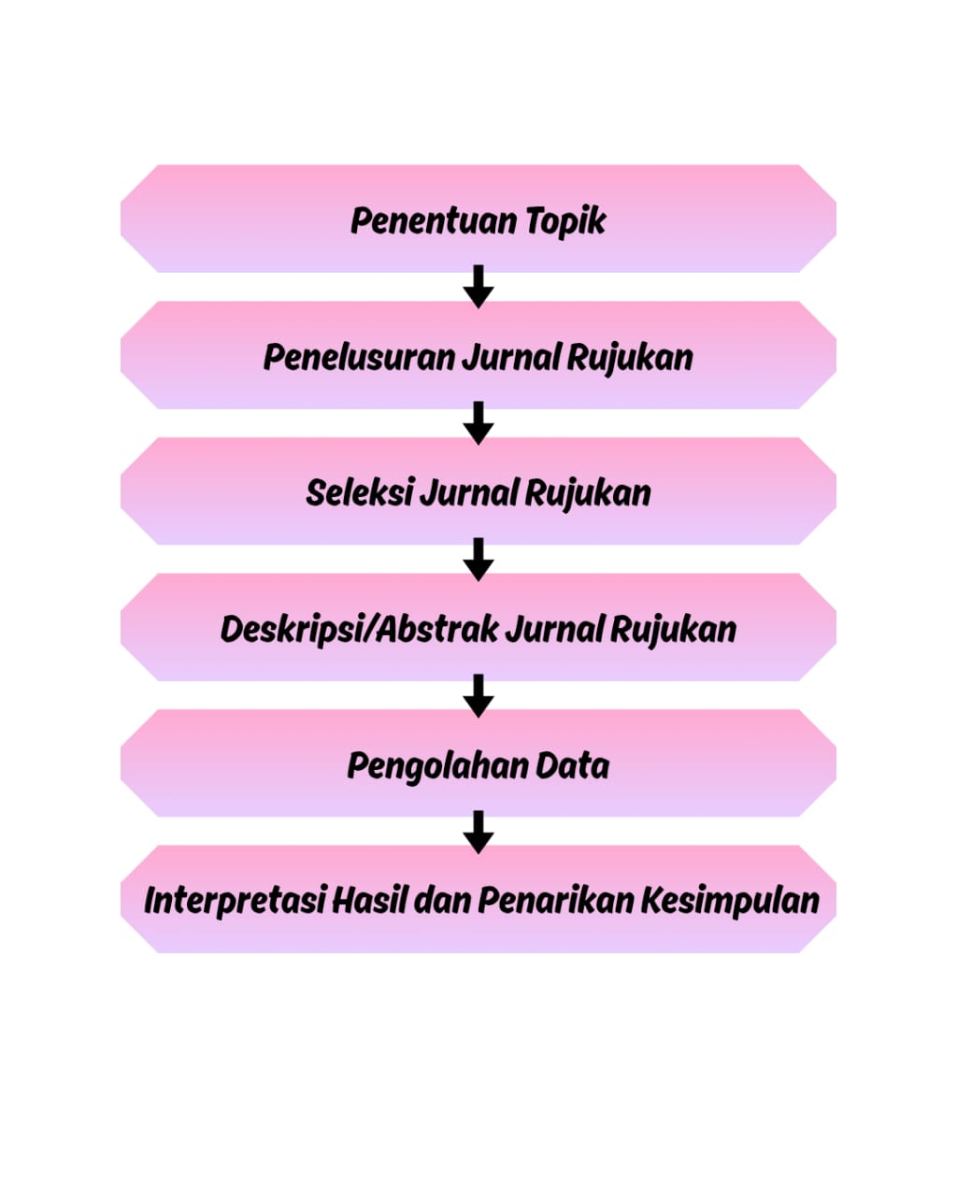

1. **LIST OF REVIEWED ARTICLES**

| **No.** | **Tahun Penerbitan** | **Judul Artikel** | **Jenis Publikasi** | **Volume/No.** | **Penulis** | **Nama Jurnal** |
| --- | --- | --- | --- | --- | --- | --- |
| 1 | 2018 | Analisis Tipologi Potensi Pariwisata di Provinsi Jawa Tengah | Artikel Jurnal | Vol. 7 No. 2 | Lutfie Juliarizka Mustofa & Titik Haryati | Economics Development Analysis Journal |
| 2 | 2014 | PENGEMBANGAN POTENSI PARIWISATA Kabupaten Sumenep, Madura, Jawa Timur (Studi Kasus: Pantai Lombang) | Artikel Jurnal | Vol. 3 No. 3 | Deddy Prasetya Maha Rani | Jurnal Politik Muda |
| 3 | - | Analisis Penentuan Sektor Basis dan Sektor Potensial di Kabupaten Lamongan | Artikel Penelitian | - | M Iqbal Wahyu Yuuhaa, Hendry Cahyono | - |
| 4 | 2018 | PENGEMBANGAN POTENSI EKONOMI DAN PENETAPAN SEKTOR UNGGULAN DI PROVINSI JAWA TIMUR WILAYAH UTARA | Artikel Jurnal | Vol. 26 No. 2 | Reza Aditama | Media Ekonomi |
| 5 | 2021 | ANALISIS LOCATION QUOTIENT DAN SHIFT SHARE SEKTOR PARIWISATA SEBAGAI INDIKATOR LEADING SECTOR DI INDONESIA | Artikel Jurnal | Vol. 8 No. 1 | Muhammad Basorudin, Aniisa Rizqi, Nadia Humairo, et al. | ECOBISMA (Jurnal Ekonomi Bisnis dan Manajemen) |
| 6 | 2017 | Analisis Kontribusi Sektor Pariwisata terhadap Produk Domestik Regional Bruto Provinsi Jawa Timur | Artikel Jurnal | Vol. 1 No. 2 | Subardini | Jurnal Ilmiah Administrasi Bisnis dan Inovasi (JIABI) |
| 7 | - | ANALISIS STRATEGI PENGEMBANGAN PARIWISATA DAERAH (Studi pada Dinas Kebudayaan dan Pariwisata Daerah Kabupaten Nganjuk) | Artikel Jurnal | Vol. 1 No. 4 | Sefira Ryalita Primadany, Mardiyono, Riyanto | Jurnal Administrasi Publik (JAP) |
| 8 | 2017 | PENGARUH POTENSI PARIWISATA TERHADAP PENYERAPAN TENAGA KERJA SEKTOR PERHOTELAN DI 9 KABUPATEN/KOTA PROVINSI JAWA TIMUR TAHUN 2012-2015 | Artikel Jurnal | Vol. 1 Jilid 3 | Ghaniy Sanaubar, Wahyu Hidayat, Hendra Kusuma | Jurnal Ilmu Ekonomi |
| 9 | 2018 | PENDEKATAN DIMENSI KUALITAS PELAYANAN, DAYA TARIK WISATA, FASILITAS, BIAYA PERJALANAN DAN PROMOSI PENGARUHNYA TERHADAP KUNJUNGAN WISATAWAN PADA OBYEK WISATA PANTAI PLENGKUNG DI KABUPATEN BANYUWANGI PROPINSI JAWA TIMUR (Upaya Pemberdayaan Pengusaha Lokal Sektor Pariwisata) | Artikel Jurnal | Vol. 10 No. 1 | Ida Bagus Gede Udiyana, Putu Kepramareni, Erlinawati | Jurnal KRISNA: Kumpulan Riset Akuntansi |
| 10 | 2024 | IMPLEMENTASI SISTEM INFORMASI GEOGRAFIS (SIG) UNTUK PEMETAAN SEKTOR PARIWISATA MENGGUNAKAN METODE WATERFALL WILAYAH JAWA TIMUR | Artikel Jurnal | Vol. 14 No. 2 | Shofa Shofiah Hilabi, Dwina Nurfauziah, Naila Nazwa Aulia, Cindy Maharani, Muhammad Ringgo Nurzaqi, Lalu Adrian Raffi Hartadi | Just IT : Jurnal Sistem Informasi, Teknologi Informasi dan Komputer |

### ****RESULTS AND DISCUSSION****

1. The article "Typological Analysis of Tourism Potential in Central Java Province" reveals that through the application of Klassen Typology, Location Quotient (LQ), Growth Ratio Model (GRM), and Overlay methods, several regencies such as Banjarnegara, Semarang, Magelang, and Kebumen were identified as tourism excellence centers. The study shows variations in potential based on tourism types such as nature, artificial, marine, religious, and health tourism. The discussion emphasizes that with proper development, these potentials can be optimized to boost regional income and create employment opportunities.
2. The article "Tourism Potential Development in Sumenep Regency, Madura, East Java (Case Study: Lombang Beach)" uses a qualitative method through interviews and document studies, revealing that Lombang Beach significantly contributes to increasing local revenue (PAD) and regional autonomy. However, the discussion also highlights several development barriers such as limited infrastructure and suboptimal promotion, suggesting the need for greater attention from the government and stakeholders.
3. In the article "Analysis of Basic and Potential Sector Determination in Lamongan Regency", quantitative methods using LQ, Shift Share, and GRM identify the basic and potential sectors. The findings indicate that agriculture serves as the main basic sector, while trade, hospitality, and services demonstrate strong competitiveness. The discussion underscores the importance of aligning development policies with local resource characteristics to transform potential sectors into regional economic growth drivers.
4. The study "Economic Potential Development and Leading Sector Determination in Northern East Java Province" presents a comprehensive analysis using Klassen Typology, LQ, and Shift Share. It identifies various leading sectors across regencies, with each having different numbers of basic sectors. The article emphasizes the strong link between increasing GRDP and utilizing leading sector potential, stressing the need for regional strategies to optimize growth through tourism and other sectors.
5. The article "Location Quotient and Shift Share Analysis of the Tourism Sector as an Indicator of Leading Sector in Indonesia" applies LQ and Shift Share to determine the role of the tourism sector as a key indicator in regional development. Findings show varying tourism sector performance across regions, establishing it as a benchmark for regional competitive advantage. The discussion notes that this analysis can guide strategic policy formulation to enhance the tourism sector's national competitiveness.
6. In the article "Analysis of the Tourism Sector Contribution to the Gross Regional Domestic Product of East Java Province", the use of Ordinary Least Squares (OLS) regression on 10 years of time-series data indicates that hotel investment and foreign tourist arrivals have a significant positive impact on GRDP. Although length of stay is not statistically significant, the study stresses that the tourism sector plays an important role in East Java’s economic growth.
7. The article "Regional Tourism Development Strategy Analysis" (Study at the Department of Culture and Tourism of Nganjuk Regency) reveals that despite having a variety of leading tourist attractions, promotional and development strategies remain inadequate. The discussion points to insufficient local government attention and suggests improvements in regulations, enhanced promotion, and empowering the tourism department with full authority to plan structured development strategies.
8. The article "Effect of Tourism Potential on Employment Absorption in the Hospitality Sector in 9 Regencies/Cities of East Java Province (2012–2015)" uses multiple linear regression with panel data to assess variables like the number of hotels, rooms, and both domestic and international tourists. The findings show that all these variables have a significant effect on employment absorption, while regional minimum wages do not. The study highlights that tourism development can expand job opportunities in the hospitality sector, contributing significantly to the regional economy.
9. The article "Approach to Service Quality Dimensions, Tourist Attractions, Facilities, Travel Costs, and Promotion on Tourist Visits to Plengkung Beach in Banyuwangi, East Java Province" uses OLS regression to show that service quality, facilities, travel costs, and promotion significantly affect tourist visit numbers. The findings stress the need to improve marketing and infrastructure to attract more tourists, with a discussion focused on empowering local entrepreneurs and improving service quality at destinations.
10. The article "Implementation of Geographic Information Systems (GIS) for Tourism Sector Mapping Using the Waterfall Method in East Java" presents the development of a web-based application that integrates geographic and tourism information. The results show that the Waterfall approach produces a structured system with clear stages, facilitating the mapping of tourist objects, travel routes, and accommodations. The discussion emphasizes the benefits of information technology in enhancing tourism data management and supporting strategic decision-making by government and industry players.

Each article presents diverse yet complementary findings in uncovering the potential and challenges of Indonesia’s tourism sector, offering a comprehensive picture for developing effective policies and regional economic development strategies.

**CONCLUSION**  
Based on the review of ten scholarly articles on the potential and challenges of tourism in East Java, it can be concluded that the tourism sector plays a vital role in driving regional economic growth, particularly by increasing the Gross Regional Domestic Product (GRDP) and creating employment opportunities. Several regions, such as Banyuwangi, Sumenep, and Lamongan, demonstrate significant potential to become leading sectors through analytical approaches such as Location Quotient (LQ), Shift Share, and Growth Ratio Model (MRP). However, the development of this sector still faces numerous challenges. The main issues identified include inadequate supporting infrastructure such as accessibility and public facilities, weak promotion and marketing strategies, low service quality and limited involvement of local actors, suboptimal use of information technology, and insufficient coordination among stakeholders. Overall, the tourism potential in East Java has not been fully optimized due to technical, managerial, and institutional obstacles that require strategic handling.

1. **Recommendations**  
   To ensure more optimal and sustainable tourism development in East Java, several strategic steps need to be taken. First, local governments should prioritize the development and improvement of basic infrastructure in tourist areas, including roads, public facilities, and digital connectivity. Second, the promotion of tourist destinations must be conducted intensively and strategically through digital media and collaboration with online travel platforms. Third, local communities must be empowered to participate actively in tourism management through training and access to entrepreneurial opportunities, so that economic benefits are widely distributed. Fourth, the use of information technology, such as geographic information systems (GIS) and web-based tourism applications, should be enhanced to improve management and service efficiency. Finally, there should be supportive regulations encouraging cross-sector collaboration and sufficient authority given to tourism agencies to formulate and implement structured development strategies. With the synergy of policy strategies, community empowerment, and technological innovation, East Java's tourism potential can be developed into a key driver of inclusive and sustainable economic development.

**REFERENCES :**

The following is a list of references compiled based on the reviewed articles:

1. Mustofa, L. J., & Haryati, T. (2018). **Analisis Tipologi Potensi Pariwisata di Provinsi Jawa Tengah**. Economics Development Analysis Journal, 7(2).
2. Maha Rani, D. P. (2014). **Pengembangan Potensi Pariwisata Kabupaten Sumenep, Madura, Jawa Timur (Studi Kasus: Pantai Lombang)**. Jurnal Politik Muda, 3(3).
3. Yuuhaa, M. I. W., & Cahyono, H. **Analisis Penentuan Sektor Basis dan Sektor Potensial di Kabupaten Lamongan**.
4. Aditama, R. (2018). **Pengembangan Potensi Ekonomi dan Penetapan Sektor Unggulan di Provinsi Jawa Timur Wilayah Utara**. Media Ekonomi, 26(2).
5. Basorudin, M., Rizqi, A., & Humairo, N. (2021). **Analisis Location Quotient dan Shift Share Sektor Pariwisata sebagai Indikator Leading Sector di Indonesia**. ECOBISMA (Jurnal Ekonomi Bisnis dan Manajemen), 8(1).
6. Subardini. (2017). **Analisis Kontribusi Sektor Pariwisata terhadap Produk Domestik Regional Bruto Provinsi Jawa Timur**. Jurnal Ilmiah Administrasi Bisnis dan Inovasi (JIABI), 1(2).
7. Primadany, S. R., Mardiyono, & Riyanto. **Analisis Strategi Pengembangan Pariwisata Daerah (Studi pada Dinas Kebudayaan dan Pariwisata Daerah Kabupaten Nganjuk)**. Jurnal Administrasi Publik (JAP), 1(4).
8. Sanaubar, G., Hidayat, W., & Kusuma, H. (2017). **Pengaruh Potensi Pariwisata terhadap Penyerapan Tenaga Kerja Sektor Perhotelan di 9 Kabupaten/Kota Provinsi Jawa Timur Tahun 2012-2015**. Jurnal Ilmu Ekonomi, 1(3).
9. Udiyana, I. B. G., Kepramareni, P., & Erlinawati. (2018). **Pendekatan Dimensi Kualitas Pelayanan, Daya Tarik Wisata, Fasilitas, Biaya Perjalanan dan Promosi Pengaruhnya terhadap Kunjungan Wisatawan pada Obyek Wisata Pantai Plengkung di Kabupaten Banyuwangi, Provinsi Jawa Timur**. Jurnal KRISNA: Kumpulan Riset Akuntansi, 10(1).
10. Hilabi, S. S., Nurfauziah, D., Aulia, N. N., Maharani, C., Nurzaqi, M. R., & Hartadi, L. A. R. (2024). **Implementasi Sistem Informasi Geografis (SIG) untuk Pemetaan Sektor Pariwisata Menggunakan Metode Waterfall Wilayah Jawa Timur**. Just IT: Jurnal Sistem Informasi, Teknologi Informasi dan Komputer, 14(2).