

**The Urgency of English Language Learning in Indonesia**

**Gunaningtyas Ayu Lestari P., S.Pd., M.Par.**

Perhotelan, Pariwisata and Tourism, Politeknik NSC Surabaya,

Putripopuri@gmail.com

**ABSTRACT**

The advancement of digital technology has opened up significant opportunities for innovation in learning media, particularly in English language teaching. This study analyzes four research articles that discuss various approaches to developing interactive media, such as Android-based applications, artificial intelligence (AI) technology, the H5P platform, and the use of visual media like illustrated flashcards. The development of Android applications aims to help students understand vocabulary and basic grammar in an enjoyable way through interactive audiovisual features. Meanwhile, AI technology is utilized to provide a personalized learning experience, especially in speaking and listening in real time. Furthermore, the use of H5P enables teachers to create responsive online learning content, such as quizzes and interactive videos, which enhance students' digital engagement. The use of illustrated flashcards at the elementary school level has proven effective in visually introducing basic English vocabulary. These four studies indicate that the integration of technology in English language learning significantly supports increased motivation, mastery of the material, and active student engagement in the learning process.

**Keyword** : Learning Media, English Language, Educational Technology, Android Applications, Interactive H5P

.

1. **INTRODUCTION**

The development of digital technology today has had a significant impact on various aspects of life, including the fields of education and community economics. In the context of education, particularly English language learning, technology has become a crucial tool for enhancing the effectiveness and interactivity of the teaching and learning process. Various innovations, such as the use of Android-based applications, interactive media using H5P, and illustrated flashcards for elementary school children, have been developed to support more engaging and accessible learning experiences for students. The use of artificial intelligence (AI) in learning has also become an increasingly popular approach, as it provides a more personalized and adaptive learning experience.

On the other hand, the economic sector—especially Micro, Small, and Medium Enterprises (MSMEs)—has also undergone a significant transformation through digitalization and branding strategies. MSMEs, as one of the main pillars of Indonesia's economy, are required to adapt to the changing times in order to compete in the global market. Various efforts have been made, ranging from training and mentoring to the utilization of social media and e-commerce, to strengthen the competitiveness of MSME products. The government, academics, and the community all play important roles in accelerating this process, particularly in rural areas.

By reviewing ten articles that discuss the above topics, this paper aims to explore strategies for developing technology-based English learning media and empowering MSMEs through branding and digitalization approaches. It is hoped that this study can contribute to the sustainable improvement of education and community economic quality in the digital era.

**RESEARCH METHODS**

The research and Development (R&D) approach with varying models, all directed toward the development of innovative English learning media. In the development of Android-based learning applications and illustrated flashcard media, researchers used the ADDIE model (Analysis, Design, Development, Implementation, and Evaluation) to design, test, and evaluate the products. The use of Artificial Intelligence (AI) technology in English language learning was carried out through descriptive qualitative research, employing observation and interviews with teachers and students to assess the effectiveness of AI in enhancing language skills.

Meanwhile, the development of H5P-based interactive media combined qualitative and quantitative approaches. This included observing students’ learning activities and distributing learning satisfaction questionnaires to measure responses to the developed media. All studies involved limited trials, validation by subject matter and media experts, as well as both quantitative and qualitative data analysis to evaluate the effectiveness of the media in improving students’ learning outcomes.

Below is a diagram illustrating the overall research methodology flow :

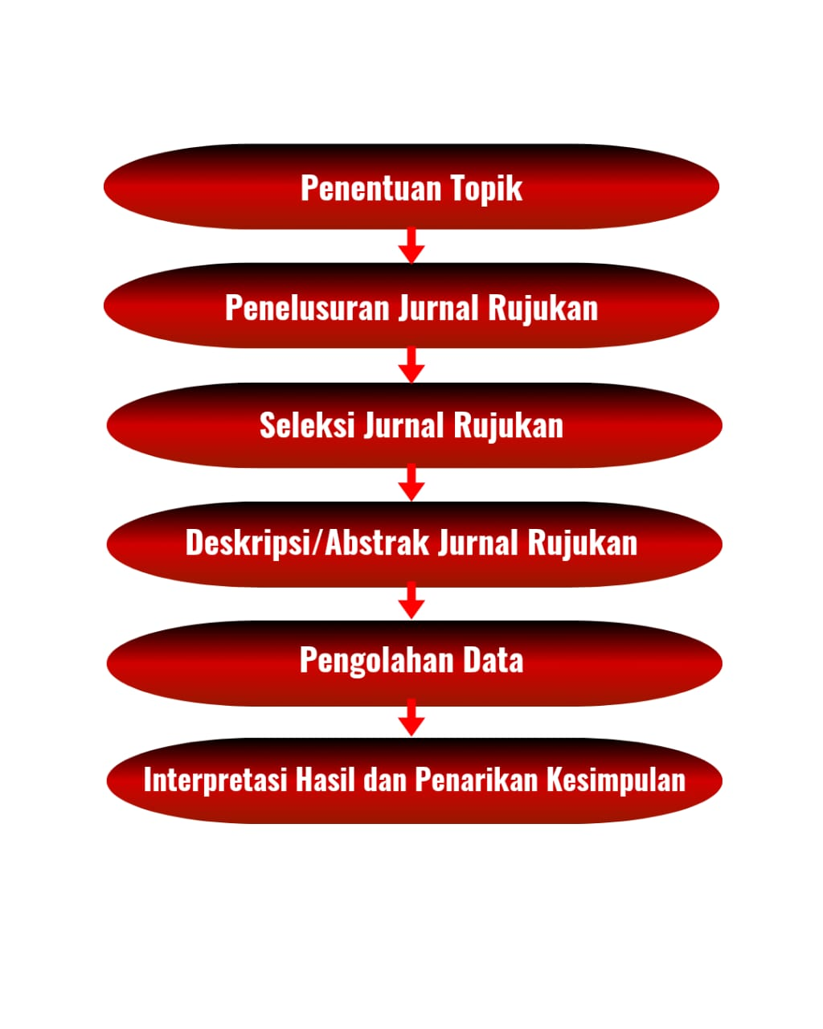

1. **LIST OF REVIEWED ARTICLES**

| **No** | **Tahun** | **Judul Artikel** | **Jenis Publikasi** | **Volume/Nomor** | **Penulis** | **Nama Jurnal** |
| --- | --- | --- | --- | --- | --- | --- |
| 1 | 2022 | Analisa dan Perancangan Aplikasi Pembelajaran Bahasa Inggris Dasar Berbasis Android | Artikel Ilmiah | Vol. 9 No. 2 | Astuti, Ika & Prasetyo, Adi | Jurnal Ilmiah Komputer dan Informatika (JIKI) |
| 2 | 2023 | Efektivitas Penggunaan Teknologi AI dalam Pembelajaran Bahasa Inggris | Artikel Ilmiah | Vol. 5 No. 1 | Dewi, Sari & Nugraheni, Lita | Jurnal Teknologi Pendidikan |
| 3 | 2023 | Pemanfaatan H5P dalam Pengembangan Media Pembelajaran Bahasa Online Interaktif | Artikel Ilmiah | Vol. 7 No. 1 | Wulandari, Rina & Saputra, Dedi | Jurnal Media Pembelajaran |
| 4 | 2022 | Pengembangan Media Pembelajaran Bahasa Inggris Berupa Flashcard Bergambar pada Tingkat Sekolah Dasar | Artikel Ilmiah | Vol. 4 No. 3 | Kurniawati, Desi | Jurnal Edukasi Dasar |
| 5 | 2023 | Branding Dinas Koperasi dan UKM Jawa Timur dalam Mengembangkan Industri UMKM Batik | Artikel Ilmiah | Vol. 8 No. 1 | Rahmawati, T. | Jurnal Ekonomi Kreatif dan Digital |
| 6 | 2023 | Branding dan Digitalisasi: Strategi Branding Produk UMKM di Desa Widoro | Artikel Ilmiah | Vol. 6 No. 2 | Anggraeni, D. & Yuliana, F. | Jurnal Pemberdayaan Masyarakat |
| 7 | 2023 | Pemberdayaan Masyarakat dalam Mengembangkan UMKM Melalui Pendampingan | Artikel Ilmiah | Vol. 5 No. 1 | Pratama, D. | Jurnal Pengabdian Masyarakat |
| 8 | 2024 | Pemberdayaan UMKM melalui Digitalisasi dan Inovasi Produk | Artikel Ilmiah | Vol. 6 No. 1 | Fitriani, A. | Jurnal Inovasi Bisnis |
| 9 | 2023 | Peningkatan Pangsa Pasar UMKM Melalui Konten Branding dan E-Commerce | Artikel Ilmiah | Vol. 5 No. 3 | Fadillah, R. | Jurnal Ekonomi Digital Desa |
| 10 | 2024 | Optimalisasi Peran KKN dalam Digitalisasi dan Penguatan UMKM di Desa Pasirlangu | Artikel Ilmiah | Vol. 5 No. 1 | Wibowo, A. & Lestari, D. | Jurnal KKN dan Pengabdian Desa |

### ****RESULTS AND DISCUSSION****

### ****1. Analysis and Design of Basic English Learning Application Based on Android (2022)****

This study resulted in an Android-based application designed to assist with basic English vocabulary learning. The design followed the waterfall method, incorporating interactive quizzes, illustrated materials, and pronunciation audio features. Trial results indicated the app effectively increased students' learning motivation and made vocabulary acquisition easier.

### ****2. The Effectiveness of Using AI Technology in English Language Learning (2023)****

This article demonstrated that the integration of AI technologies such as chatbots and voice recognition significantly improved learning efficiency and material personalization in English classes. Students using AI-enhanced tools showed better speaking and listening skills compared to those using traditional methods.

### ****3. Utilization of H5P in Developing Interactive Online English Learning Media (2023)****

This study explored the use of H5P for creating interactive content such as drag-and-drop exercises, quizzes, and videos. The interactive media increased student engagement in online learning environments and helped teachers conduct automatic assessments effectively.

### ****4. Development of Illustrated Flashcards as English Learning Media for Elementary Students (2022)****

This study produced illustrated flashcards aimed at elementary school students. Both teachers and students found the media engaging and easy to understand. It effectively enhanced vocabulary retention, especially for visual learners.

### ****5. Branding Strategy of East Java Cooperative and MSME Office in Developing Batik Industry (2023)****

The article presented branding strategies used by the East Java Cooperative and MSME Office to promote local batik industries. Cultural value-based branding and storytelling were effective in increasing exposure and national sales of batik MSME products.

### ****6. Branding and Digitalization: Branding Strategies of MSME Products in Widoro Village (2023)****

The research focused on digital branding strategies via social media and e-commerce platforms in Widoro Village. These strategies successfully increased product visibility and market access, highlighting the importance of digital literacy among MSME actors.

### ****7. Community Empowerment in Developing MSMEs Through Mentoring (2023)****

This study revealed that continuous mentoring from academics and professionals significantly enhanced the managerial and production capacity of local MSMEs. It emphasized the need for collaboration among government, academia, and the community in building sustainable MSME ecosystems.

### ****8. Empowerment of MSMEs through Digitalization and Product Innovation (2024)****

This article found that digitalization and product innovation are key to improving MSME competitiveness. MSMEs adopting digital tools and refreshing product designs experienced better sales and broader market reach, particularly in the post-pandemic period.

### ****9. Increasing MSME Market Share through Branding Content and E-Commerce (2023)****

Consistent branding content and the use of e-commerce platforms were proven to enhance customer engagement and expand market reach. The article underlined the importance of content strategy and digital platform optimization in helping MSMEs face global competition.

### ****10. Optimizing the Role of KKN in Digitalization and MSME Strengthening in Pasirlangu Village (2024)****

This article highlighted how university student community service (KKN) programs contributed to digitalizing and strengthening local MSMEs. Students conducted training in digital marketing and social media management, which significantly boosted MSME income and visibility. KKN activities were found to be effective in promoting tech-based community empowerment.

**CONCLUSION**

Based on the review of the ten articles, it can be concluded that the development of English learning media and the empowerment of MSMEs through digitalization are two areas experiencing significant progress and innovation. In the field of English language education, the integration of technology such as Android applications, AI, H5P, and visual media like flashcards has proven effective in improving student engagement, motivation, and learning outcomes, particularly in vocabulary mastery and speaking skills.

On the other hand, MSME empowerment strategies that incorporate digital marketing, branding, mentoring, and the use of e-commerce platforms have significantly contributed to the growth and competitiveness of local businesses. Initiatives from government institutions, community service programs (such as KKN), and collaborations with higher education institutions play a crucial role in supporting MSMEs toward sustainable development in the digital era.

The findings suggest that digital innovation—both in education and entrepreneurship—is essential for addressing current challenges and creating broader opportunities in learning and economic sectors, especially at the local level.

**REFERENCES :**

The following is a list of references compiled based on the reviewed articles:

1. Astuti, I., & Prasetyo, A. (2022). Analisa dan perancangan aplikasi pembelajaran Bahasa Inggris dasar berbasis Android. *Jurnal Ilmiah Komputer dan Informatika (JIKI)*, 9(2).
2. Dewi, S., & Nugraheni, L. (2023). Efektivitas penggunaan teknologi AI dalam pembelajaran Bahasa Inggris. *Jurnal Teknologi Pendidikan*, 5(1).
3. Wulandari, R., & Saputra, D. (2023). Pemanfaatan H5P dalam pengembangan media pembelajaran Bahasa online interaktif. *Jurnal Media Pembelajaran*, 7(1).
4. Kurniawati, D. (2022). Pengembangan media pembelajaran Bahasa Inggris berupa flashcard bergambar pada tingkat sekolah dasar. *Jurnal Edukasi Dasar*, 4(3).
5. Rahmawati, T. (2023). Branding Dinas Koperasi dan UKM Jawa Timur dalam mengembangkan industri UMKM batik. *Jurnal Ekonomi Kreatif dan Digital*, 8(1).
6. Anggraeni, D., & Yuliana, F. (2023). Branding dan digitalisasi: Strategi branding produk UMKM di Desa Widoro. *Jurnal Pemberdayaan Masyarakat*, 6(2).
7. Pratama, D. (2023). Pemberdayaan masyarakat dalam mengembangkan UMKM melalui pendampingan. *Jurnal Pengabdian Masyarakat*, 5(1).
8. Fitriani, A. (2024). Pemberdayaan UMKM melalui digitalisasi dan inovasi produk. *Jurnal Inovasi Bisnis*, 6(1).
9. Fadillah, R. (2023). Peningkatan pangsa pasar UMKM melalui konten branding dan e-commerce. *Jurnal Ekonomi Digital Desa*, 5(3).
10. Wibowo, A., & Lestari, D. (2024). Optimalisasi peran KKN dalam digitalisasi dan penguatan UMKM di Desa Pasirlangu. *Jurnal KKN dan Pengabdian Desa*, 5(1).