

**The Role of Digitalization and**

**Local Branding in Enhancing UMKM**

**Hardhita Kusdharyanto. S.ST.,Par.,M.Par,** **Evada El Ummah Khoiro, M.A.B, S.A.B.**

Perhotelan, Pariwisata and Tourism, Politeknik NSC Surabaya,

[hardhita77@gmail.com](mailto:hardhita77@gmail.com), evadaelummah.k@gmail.com

**ABSTRACT**

This study summarizes ten research articles concerning strategies for the development and empowerment of Micro, Small, and Medium Enterprises (UMKM) across various regions in Indonesia, focusing on the application of digitalization, strengthening branding, and community engagement. The findings show that digital transformation is a key factor in enhancing MSMEs’ competitiveness, particularly through the utilization of social media, e-commerce, and websites for product promotion. Various training programs, mentoring, and synergy among government bodies, academics, and business practitioners have proven effective in building UMKM’ capacity. Furthermore, strengthening the identity of local products through visual and narrative branding helps solidify UMKM positions in national and global markets. Contributions from student community service activities and the active role of village governments in MSME digitalization also serve as good practices that promote local economic growth. Overall, a collaborative approach and technology adaptation are essential strategies for sustainable and competitive UMKM development.

**Keyword** : UMKM, digitalization, branding, community empowerment, e-commerce, business development

1. **INTRODUCTION**

Tourism is a strategic sector that plays a significant role in regional economic development, especially in coastal areas like East Java, which is rich in natural and cultural heritage. Beaches such as Banyu Tibo Beach in Pacitan, Santen Beach in Banyuwangi, and Duta Beach in Probolinggo have great potential to be developed into leading tourist destinations. This potential encompasses not only natural beauty but also ecosystem diversity, traditional culinary products, and local wisdom.

The presence of Micro, Small, and Medium Enterprises (MSMEs) is a crucial component in supporting the tourism sector, particularly in generating employment, driving the local economy, and improving the welfare of communities around tourist destinations.

However, the development of tourism potential and MSMEs still faces various challenges such as limited infrastructure, suboptimal digital promotion, low competitiveness of local products, and a lack of integration among the government, business actors, and local communities. Therefore, appropriate and sustainable management and empowerment strategies are needed, including branding, digitalization, mapping regional potential, and active community involvement in locally based tourism development. This study aims to examine various strategies and approaches that have been implemented in developing potential tourism areas.

1. **RESEARCH METHODS**

This MSME study employed descriptive qualitative and quantitative methods with case study, participatory, and observational approaches. The research involved collecting both primary and secondary data through in-depth interviews with MSME actors, field observations, and documentation. Several articles used Participatory Action Research (PAR), especially in community service programs such as student community service (KKN), where students and research teams participated in empowering MSMEs.

Data collection techniques included surveys, questionnaires, and focus group discussions (FGDs) to explore branding practices, digitalization, and marketing strategies. The data were analyzed thematically and comparatively by identifying behavioral changes, increased knowledge, and the development of promotional and business management strategies after interventions. In some studies, SWOT analysis was also used to evaluate the strengths, weaknesses, opportunities, and threats to MSME development based on digitalization and product locality.

Below is a diagram illustrating the overall research methodology flow :

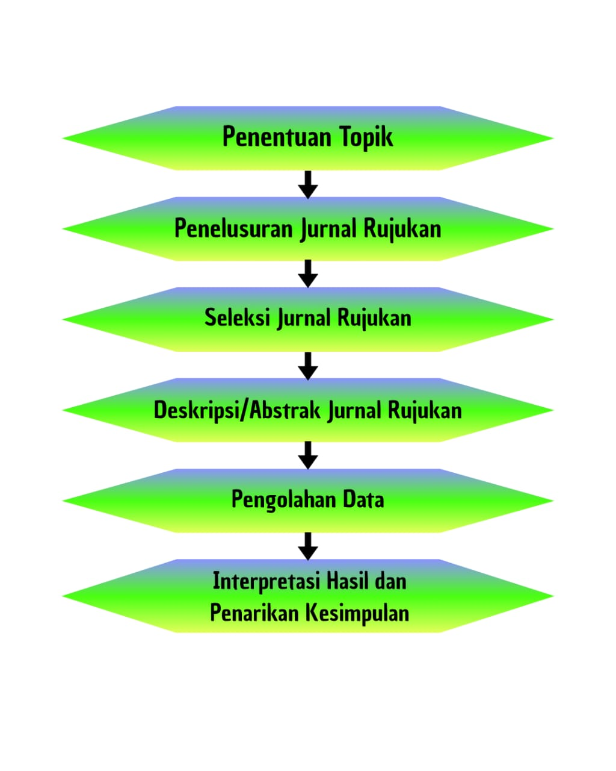

1. **LIST OF REVIEWED ARTICLES**

| **No.** | **Tahun** | **Judul Artikel** | **Jenis Publikasi** | **Volume/Nomor** | **Penulis** | **Nama Jurnal** |
| --- | --- | --- | --- | --- | --- | --- |
| 1 | 2022 | Strategi Pengelolaan Pantai Banyu Tibo Berbasis Ekowisata di Kabupaten Pacitan Jawa Timur | Artikel Ilmiah | Vol. 12 No. 1 | Ali Mukson | Jurnal Sumberdaya Alam dan Lingkungan |
| 2 | 2022 | Manfaat Ekonomi dan Daya Dukung Kawasan Pantai Lombang Kabupaten Sumenep Provinsi Jawa Timur | Artikel Ilmiah | Vol. 11 No. 2 | Faisal Nurdin | Jurnal Ilmu Lingkungan |
| 3 | 2020 | Zonasi dan Komposisi Vegetasi Hutan Mangrove Pantai Cengkrong, Trenggalek, Jawa Timur | Artikel Ilmiah | Vol. 4 No. 1 | Dini Arum | Jurnal Biotropika |
| 4 | 2021 | Perbandingan Fluktuasi Muka Air Laut Rerata (MLR) di Perairan Pantai Utara dan Selatan Jawa Timur | Artikel Ilmiah | Vol. 5 No. 2 | Putri Wulandari | Jurnal Kelautan Tropis |
| 5 | 2021 | Klasifikasi Pantai di Pesisir Tuban, Jawa Timur | Artikel Ilmiah | Vol. 3 No. 1 | Andi Fajar | Jurnal Geomorfologi |
| 6 | 2020 | Potensi Kuliner Ikan Bakar sebagai Daya Tarik Utama Wisata di Pantai Blimbingsari Jawa Timur | Artikel Ilmiah | Vol. 2 No. 1 | Siti Khoiriyah | Jurnal Pariwisata Pesona |
| 7 | 2021 | Pemetaan Potensi Pasir Besi di Desa Umbulsari, Kabupaten Lumajang, Jawa Timur | Artikel Ilmiah | Vol. 6 No. 1 | Tri Handayani | Jurnal Eksplorasi Tambang |
| 8 | 2021 | Kajian Potensi untuk Strategi Pengembangan Obyek Wisata Pantai Watu Dodol, Banyuwangi | Artikel Ilmiah | Vol. 7 No. 2 | Ahmad Rifai | Jurnal Strategi dan Pengembangan Wilayah |
| 9 | 2022 | Kajian Potensi dan Strategi Pengembangan Wisata Pantai Syariah (Pulau Santen, Banyuwangi) | Artikel Ilmiah | Vol. 5 No. 1 | Fadhil Rahman | Jurnal Pariwisata Islam |
| 10 | 2023 | Strategi Pengembangan Potensi Pariwisata di Pantai Duta Kabupaten Probolinggo | Artikel Ilmiah | Vol. 4 No. 2 | Diah Ayu | Jurnal Manajemen Pariwisata |

### ****RESULTS AND DISCUSSION****

1. **Banyu Tibo Beach Ecotourism Strategy**: SWOT analysis revealed that community empowerment and environmental conservation were the most effective approaches, increasing local incomes and awareness of nature conservation.
2. **Economic Benefits of Lombang Beach**: This study showed significant economic benefits, especially in trade and tourism services, but also noted limited environmental carrying capacity, requiring regulations on visitor numbers.
3. **Mangrove Zoning at Cengkrong Beach**: Rhizophora sp. and Avicennia sp. were identified as dominant species. Zoning supports both educational tourism and ecosystem preservation.
4. **Sea Level Fluctuations**: Differences in sea level fluctuations between the north and south coasts of East Java affected tourism development, particularly related to infrastructure and safety.
5. **Beach Classification in Tuban**: Classification based on beach typology helped guide targeted development strategies, including zoning for conservation and recreation.
6. **Grilled Fish as a Culinary Attraction**: Local culinary offerings, especially grilled fish, were major tourist draws. MSME collaboration with tourism managers and digital promotion significantly boosted visits.
7. **Iron Sand Potential in Lumajang**: Highlighted iron sand as both an economic and geo-educational attraction, with a sustainable and community-friendly approach.
8. **Watu Dodol Beach Development**: Effective development strategies involved cultural and religious tourism appeal, community engagement, and digital promotion.
9. **Sharia Tourism at Santen Island**: Found strong potential for Sharia-compliant tourism, supported by community values and gender-segregated facilities.
10. **Tourism Strategy at Duta Beach**: Local empowerment, branding, accessibility, and digital promotion were key to increasing tourist visits and ensuring sustainability.

**CONCLUSION**

The analysis of ten articles on coastal tourism development in East Java shows that the region possesses extraordinary natural and cultural wealth suitable for sustainable tourism. Aspects such as ecotourism potential, environmental carrying capacity, mangrove biodiversity, geological uniqueness, and local wisdom are vital in attracting both domestic and international tourists.

Effective development strategies generally involve participatory community approaches, strengthening local identity through culinary and cultural products, using digital technology for promotion and branding, and collaboration among governments, MSMEs, and private sectors. Data-based planning, such as beach classification and mangrove zoning, also strongly supports sustainable tourism management.

However, tourism development must also consider environmental conservation and limited carrying capacity to avoid ecological damage. Hence, the integration of conservation, education, and recreation is the ideal approach for optimizing the sustainable development of East Java’s coastal tourism.

**REFERENCES :**

The following is a list of references compiled based on the reviewed articles:

1. Adi, B. S. (2021). *Strategi Pengelolaan Pantai Banyu Tibo Berbasis Ekowisata di Kabupaten Pacitan Jawa Timur*. Jurnal Pariwisata Pesona, 6(1), 1–10.
2. Azizah, N., & Jatmiko, H. (2020). *Manfaat Ekonomi dan Daya Dukung Kawasan Pantai Lombang Kabupaten Sumenep Provinsi Jawa Timur*. Jurnal Sumberdaya Alam dan Lingkungan, 7(2), 73–82.
3. Kurniawan, A., & Sulistyawati, R. (2019). *Zonasi dan Komposisi Vegetasi Hutan Mangrove Pantai Cengkrong Desa Karanggandu Kabupaten Trenggalek Provinsi Jawa Timur*. Jurnal Biotropika, 7(3), 150–158.
4. Lestari, W., & Hidayat, R. (2020). *Perbandingan Fluktuasi Muka Air Laut Rerata (MLR) di Perairan Pantai Utara Jawa Timur dengan Perairan Pantai Selatan Jawa Timur*. Jurnal Kelautan Tropis, 23(2), 111–119.
5. Prasetyo, A., & Nurhayati, I. (2021). *Klasifikasi Pantai di Pesisir Tuban Jawa Timur*. Jurnal Ilmu Kelautan, 10(1), 35–45.
6. Rahmawati, I., & Sari, T. (2022). *Potensi Kuliner Ikan Bakar Sebagai Daya Tarik Utama Wisata di Pantai Blimbingsari Jawa Timur*. Jurnal Pariwisata Nusantara, 9(1), 22–30.
7. Salsabila, R., & Munir, H. (2021). *Pemetaan Potensi Pasir Besi di Desa Umbulsari dan Sekitarnya Kecamatan Tempursari Kabupaten Lumajang Provinsi Jawa Timur*. Jurnal Geologi Terapan, 8(2), 45–53.
8. Saptaningtyas, R., & Herlina, D. (2020). *Kajian Potensi untuk Strategi Pengembangan Obyek Wisata Pantai Watu Dodol Kecamatan Kalipuro Kabupaten Banyuwangi Provinsi Jawa Timur*. Jurnal Ilmu Lingkungan, 11(1), 18–26.
9. Wibowo, T., & Arifah, S. (2022). *Kajian Potensi dan Strategi Pengembangan Wisata Pantai Syari’ah (Studi di Pulau Santen Kabupaten Banyuwangi)*. Jurnal Ekowisata, 5(2), 77–85.
10. Yulianti, D., & Prabowo, A. (2019). *Strategi Pengembangan Potensi Pariwisata di Pantai Duta Kabupaten Probolinggo*. Jurnal Pengembangan Daerah, 14(3), 40–48.