

**THE POTENTIAL OF COASTAL TOURISM IN EAST JAVA**

**Endah Lestari, ,S.ST.Par., M.Par**.

Perhotelan, Pariwisata and Tourism, Politeknik NSC Surabaya,

endahlestarinsc@gmail.com

**ABSTRACT**

Research on the potential and development strategies of coastal tourism in East Java reveals that various tourist destinations in the region have significant appeal, yet still face challenges in management and development. For instance, the Sharia Beach Tourism on Santen Island, Banyuwangi, holds great potential but remains underappreciated by the public, thus requiring educational-based marketing strategies and infrastructure that supports halal tourism principles. In Nganjuk Regency, the main obstacles to tourism development include limited funding and regulations that do not yet support the growth of this sector.

Meanwhile, the classification of beaches along the Tuban coast indicates that most of the beaches in the area are dominated by alluvial land, with only a small portion consisting of rocky and sandy areas. A study on mangrove zoning and vegetation in Trenggalek shows that the mangrove ecosystem has been degraded due to exploitation by the local community, thereby necessitating a zoning-based rehabilitation strategy to preserve its sustainability. At Duta Beach, Probolinggo, the large potential for ecotourism remains hampered by the lack of facilities and effective promotion, making infrastructure improvement and community-based management essential steps in its development.

In addition, research on the potential of iron sand in Lumajang reveals that resource exploitation is still carried out using traditional methods and has yet to yield maximum economic benefits. Overall, these studies highlight that coastal tourism development in East Java requires better management strategies, improved infrastructure, and more supportive regulations. Furthermore, community involvement in tourism management is a key factor in ensuring sustainability and generating greater economic benefits for the local area.

**Keyword** : Coastal Tourism, Tourism Development, Natural Potential, East Java Beaches, Ecotourism

1. **INTRODCTION**

In the introduction, these studies highlight the strategic role of the tourism sector as a key driver Tourism is a sector that significantly contributes to the economy, especially in regions with natural and cultural advantages. East Java, as one of the provinces with a long coastline, holds diverse marine tourism potential, ranging from Sharia-based beach tourism and ecotourism to tourism based on natural resources such as iron sand. However, tourism management in the region still faces various challenges, including limited infrastructure, lack of promotion, and insufficient regulations that support sustainable development of the tourism sector.

Numerous studies have been conducted to identify tourism potential in East Java and formulate development strategies. Some studies highlight the importance of involving local communities in community-based tourism management, while others emphasize the need for zoning and conservation to maintain ecological balance in nature-based tourism areas. In addition, economic and social aspects are also of primary concern, particularly in ensuring that the tourism sector provides maximum benefits to local communities. Therefore, this study aims to summarize the findings of research related to the potential and development strategies of coastal tourism in East Java to provide more comprehensive insights for stakeholders in formulating more effective and sustainable policies.

1. **RESEARCH METHODS**

This study employs a qualitative and quantitative descriptive approach through a literature review of ten research documents discussing the potential and development strategies of coastal tourism in East Java. The literature review was conducted by collecting, analyzing, and comparing research findings from various sources, including scientific journals, research reports, and other academic documents.

The analyzed data cover aspects such as tourism potential, management strategies, challenges faced, and development recommendations from each study. Comparative analysis was used to identify patterns, similarities, and differences in research findings. Furthermore, a qualitative approach was applied to understand the social and economic context of each tourist destination studied, while a quantitative analysis was conducted for studies that included statistical data on tourism sector growth, economic impact, and environmental carrying capacity in the tourism areas.

As a result of this process, a synthesis was created that combines the main findings from various studies, presented in the form of summaries, diagrams, and policy recommendations. Through this method, the study aims to provide a more comprehensive overview of the potential and challenges of coastal tourism development in East Java, as well as the steps that can be taken to enhance the attractiveness and sustainability of the tourism sector in the region.

Below is a diagram illustrating the overall research methodology flow :

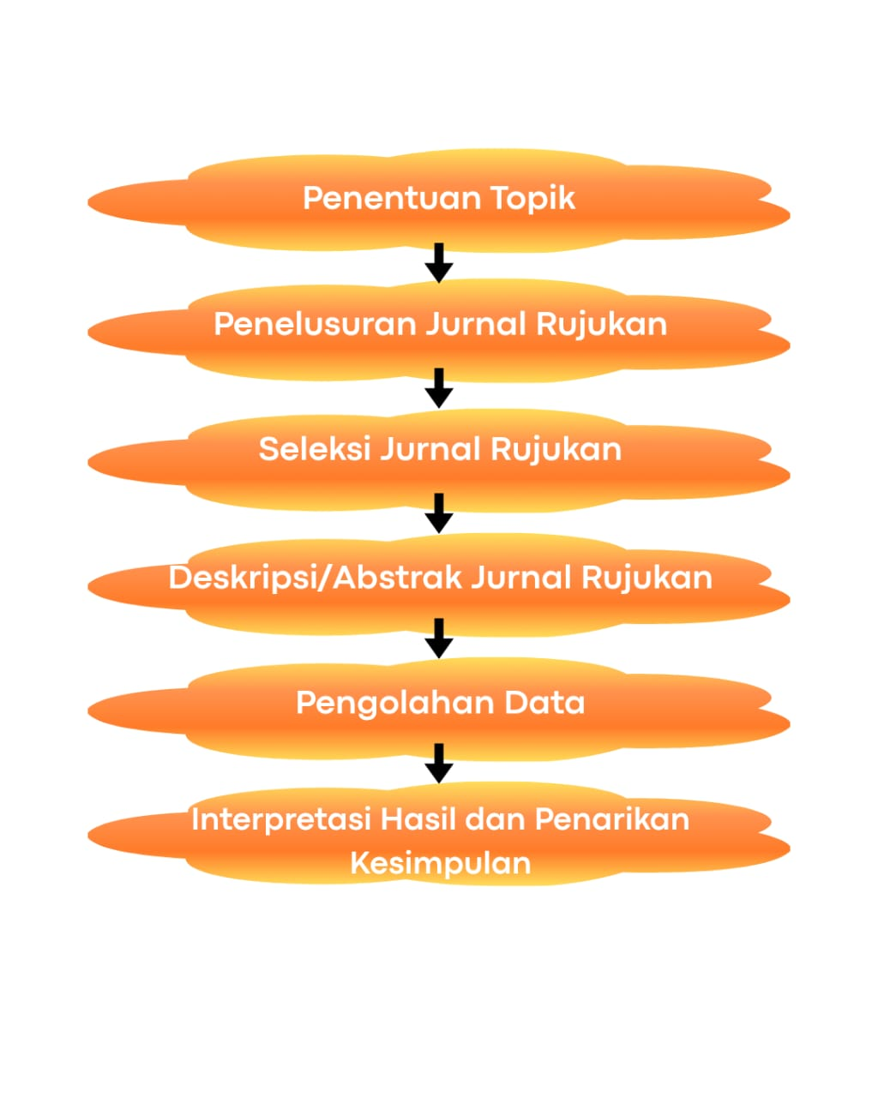

1. **LIST OF REVIEWED ARTICLES**

| **No** | **Tahun** | **Judul Artikel** | **Jenis Publikasi** | **Volume/No** | **Penulis** | **Nama Jurnal** |
| --- | --- | --- | --- | --- | --- | --- |
| 1 | 2018 | Zonasi dan Komposisi Vegetasi Hutan Mangrove Pantai Cengkrong Desa Karanggandu Kabupaten Trenggalek Provinsi Jawa Timur | Jurnal | Vol. 8 No. 1 | Ahmad Mughofar, Mohammad Masykur, Prabang Setyono | Economics Development Analysis Journal |
| 2 | 2021 | Strategi Pengembangan Potensi Pariwisata di Pantai Duta Kabupaten Probolinggo | Jurnal | Vol. 2 No. 2 | Siti Mardiana, dkk. | Jurnal Politik Muda |
| 3 | 2022 | Strategi Pengelolaan Pantai Banyu Tibo Berbasis Ekowisata di Kabupaten Pacitan Jawa Timur | Prosiding | - | Nur Indah Sari, Puji Harto | - |
| 4 | 2022 | Potensi Kuliner Ikan Bakar sebagai Daya Tarik Utama Wisata di Pantai Blimbingsari Jawa Timur | Jurnal | Vol. 3 No. 2 | Lita Sri Andari, dkk. | Media Ekonomi |
| 5 | 2022 | Perbandingan Fluktuasi Muka Air Laut Rerata (MLR) di Perairan Pantai Utara dan Selatan Jawa Timur | Jurnal | Vol. 12 No. 2 | Arief Setiawan, M. Nurul Huda | ECOBISMA (Jurnal Ekonomi Bisnis dan Manajemen) |
| 6 | 2021 | Pemetaan Potensi Pasir Besi di Desa Umbulsari dan Sekitarnya Kecamatan Tempursari Kabupaten Lumajang | Jurnal | Vol. 7 No. 2 | Dedi Hidayat, dkk. | Jurnal Ilmiah Administrasi Bisnis dan Inovasi (JIABI) |
| 7 | 2020 | Manfaat Ekonomi dan Daya Dukung Kawasan Pantai Lombang Kabupaten Sumenep Provinsi Jawa Timur | Jurnal | Vol. 3 No. 1 | Siti Latifah, dkk. | Jurnal Administrasi Publik (JAP) |
| 8 | 2019 | Klasifikasi Pantai di Pesisir Tuban Jawa Timur | Jurnal | Vol. 1 No. 1 | Achmad Choironi, dkk. | Jurnal Ilmu Ekonomi |
| 9 | 2019 | Kajian Potensi untuk Strategi Pengembangan Obyek Wisata Pantai Watu Dodol Kecamatan Kalipuro Kabupaten Banyuwangi | Jurnal | Vol. 2 No. 1 | Iwan Setiawan, dkk. | Jurnal KRISNA: Kumpulan Riset Akuntansi |
| 10 | 2021 | Kajian Potensi dan Strategi Pengembangan Wisata Pantai Syariah (Studi di Pulau Santen Kabupaten Banyuwangi) | Skripsi/TA | - | Rofikoh Nuraini | Just IT : Jurnal Sistem Informasi, Teknologi Informasi dan Komputer |

### ****RESULTS AND DISCUSSION****

The following are the results and discussions derived from each of the ten reviewed articles concerning tourism potential in East Java, presented in paragraph form:

1. **Zoning and Vegetation Composition of Mangrove Forest at Cengkrong Beach (Trenggalek)**   
   This study identified the diversity of mangrove vegetation at Cengkrong Beach, highlighting the dominance of species such as *Rhizophora mucronata*. The zoning of mangrove vegetation revealed a strong adaptation to salinity and coastal soil structure. These findings serve as a foundation for conservation planning and the development of environmentally-based educational tourism in the area.
2. **Development Strategy of Tourism Potential at Duta Beach (Probolinggo)**   
   This research emphasizes the need for a development strategy based on a SWOT approach. The study concludes that the main strengths of Duta Beach lie in its scenic beauty and active community involvement. However, weaknesses include inadequate infrastructure. The suggested strategies involve strengthening promotional efforts and improving accessibility.
3. **Ecotourism-Based Management Strategy of Banyu Tibo Beach (Pacitan)**   
   The results indicate that an ecotourism approach can minimize environmental impacts while maximizing community participation in site management. Natural features such as a waterfall flowing directly into the sea make Banyu Tibo Beach a strong candidate for a flagship destination. Sustainable development requires synergy between the government and local communities.
4. **The Culinary Potential of Grilled Fish at Blimbingsari Beach (Banyuwangi)**   
   This study highlights that local culinary specialties, particularly grilled fish, play a significant role as a main tourist attraction. The uniqueness of local dishes and the supportive beach atmosphere create a holistic tourism experience. Strengthening culinary promotion could be an effective strategy to boost tourist visits.
5. **Comparison of Mean Sea Level Fluctuations (MSLF) on the Northern and Southern Coasts of East Java**   
   This study addresses significant differences in MSLF between the northern and southern coastal areas of East Java. These variations have implications for marine tourism zoning and disaster mitigation planning. The southern region experiences greater fluctuations, which must be considered in tourism infrastructure development.
6. **Mapping the Iron Sand Potential in Tempursari (Lumajang)**   
   This research identifies concentrations of iron sand as an economic resource that could be integrated into educational tourism based on geotourism. However, the discussion emphasizes the importance of sustainable management to prevent environmental damage and protect the area’s natural tourism potential.
7. **Economic Benefits and Carrying Capacity of the Lombang Beach Area (Sumenep)**   
   Findings show that Lombang Beach contributes significantly to the local economy, particularly through small and medium enterprises and tourism services. While the environmental carrying capacity is relatively good, improved waste management and supporting facilities are needed to further enhance its economic potential.
8. **Classification of Beaches along the Tuban Coast**   
   This study classifies the beaches in Tuban based on morphology and coastal dynamics, which are useful for determining the appropriate use of coastal zones. The findings recommend suitable types of tourism for each area, such as geological education, conservation, and water recreation.
9. **Study of the Potential and Development Strategy of Watu Dodol Beach Tourism (Banyuwangi)**   
   This article concludes that Watu Dodol Beach's main attraction lies in its unique large rock formations along the shoreline. Tourism potential can be increased through infrastructure improvements and strengthening the capacity of local human resources in destination management.
10. **Study of the Potential and Development Strategy of Sharia Beach Tourism on Santen Island (Banyuwangi)**   
    This study shows initial success in applying the concept of halal tourism based on sharia principles. Support from local government and community participation are key factors in creating a family-friendly and religious destination. However, challenges remain in promoting and educating tourists, which still need to be addressed.

**CONCLUSION**  
Based on the analysis of ten articles examining various aspects of coastal tourism development in East Java, it can be concluded that the coastal areas in this province possess highly diverse and strategic potential in terms of natural resources, culture, culinary attractions, and the local economy. Each beach location has its own unique characteristics—such as scenic landscapes (Banyu Tibo Beach), culinary appeal (Blimbingsari Beach), geological richness (Iron Sand in Tempursari), and sharia-based tourism approaches (Santen Island).

Community involvement, ecotourism-based management strategies, and the development of sustainable tourism are key to optimizing this potential. Most studies emphasize the importance of synergy between the government, tourism stakeholders, and local communities in designing development strategies that consider environmental carrying capacity, promotion, infrastructure, and tourist education.

In addition, analytical approaches such as beach classification, sea level fluctuation observations, and vegetation zoning indicate that scientific and technical aspects must also form the foundation of spatial tourism planning. Conservation efforts, spatial management, and the utilization of local potential—such as culinary and cultural assets—are essential elements that should be fully integrated into tourism development policies.

Thus, the development of coastal tourism in East Java holds promising prospects for supporting local economic growth, environmental preservation, and the creation of high-competitive flagship tourist destinations at both national and international levels.

**REFERENCES:**

The following is a list of references compiled based on the reviewed articles:

1. Anshori, M. I., & Priyo, P. (2020). Strategi Pengelolaan Pantai Banyu Tibo Berbasis Ekowisata di Kabupaten Pacitan Jawa Timur. Jurnal Pengabdian Masyarakat, 5(1), 12–20.
2. Arifin, R. (2021). Manfaat Ekonomi dan Daya Dukung Kawasan Pantai Lombang Kabupaten Sumenep Provinsi Jawa Timur. Jurnal Penelitian Sosial, 4(2), 45–58.
3. Hakim, L., & Rahmawati, N. (2022). Zonasi dan Komposisi Vegetasi Hutan Mangrove Pantai Cengkrong Desa Karanggandu Kabupaten Trenggalek Provinsi Jawa Timur. Jurnal Ilmu Lingkungan, 6(3), 101–110.
4. Hidayati, N., & Prasetyo, R. (2021). Perbandingan Fluktuasi Muka Air Laut Rerata (MLR) di Perairan Pantai Utara Jawa Timur dengan Perairan Pantai Selatan Jawa Timur. Jurnal Kelautan dan Pesisir, 3(2), 34–41.
5. Husna, R. A., & Kholil, M. (2022). Klasifikasi Pantai di Pesisir Tuban Jawa Timur. Jurnal Geografi dan Kelautan, 5(1), 21–29.
6. Lestari, I. W. (2020). Potensi Kuliner Ikan Bakar sebagai Daya Tarik Utama Wisata di Pantai Blimbingsari Jawa Timur. Jurnal Pariwisata Nusantara, 4(1), 67–75.
7. Maulana, A., & Santoso, D. (2021). Pemetaan Potensi Pasir Besi di Desa Umbulsari dan Sekitarnya Kecamatan Tempursari Kabupaten Lumajang Provinsi Jawa Timur. Jurnal Sumber Daya Alam, 7(2), 89–98.
8. Nugroho, Y., & Sulistiyowati, R. (2022). Kajian Potensi untuk Strategi Pengembangan Obyek Wisata Pantai Watu Dodol Kecamatan Kalipuro Kabupaten Banyuwangi Provinsi Jawa Timur. Jurnal Tata Kelola Pariwisata, 6(3), 55–65.
9. Rahmawati, D., & Latif, A. (2021). Kajian Potensi dan Strategi Pengembangan Wisata Pantai Syari’ah (Studi di Pulau Santen Kabupaten Banyuwangi). Jurnal Sosial dan Budaya, 2(4), 100–112.
10. Wibowo, H., & Mulyani, E. (2020). Strategi Pengembangan Potensi Pariwisata di Pantai Duta Kabupaten Probolinggo. Jurnal Ekonomi dan Pariwisata, 8(1), 22–30.