

**A Study on English Language Learning Techniques**

**Gunaningtyas Ayu Lestari P., S.Pd., M.Par.**

Perhotelan, Pariwisata and Tourism, Politeknik NSC Surabaya,

Putripopuri@gmail.com

**ABSTRACT**

Research and development in English language learning continue to advance in line with the growing demand for more innovative, engaging, and effective approaches. The ten studies reviewed in this document present a variety of perspectives and solutions for English language learning, particularly within the Indonesian context. These studies encompass the development of Android and J2ME-based learning applications, the use of social media platforms such as TikTok and design tools like Canva, as well as the integration of cutting-edge technologies such as AI and interactive platforms like H5P.

Several studies discuss the effectiveness of teaching methods such as project-based learning and classroom action research in improving students' speaking skills and engagement. Other studies explore modified traditional media, such as the use of illustrated flashcards to strengthen vocabulary mastery at the elementary school level.

The research methods employed include qualitative, quantitative, and classroom action approaches, with findings indicating that the integration of appropriate technology and media can significantly enhance students' learning outcomes. The implementation of innovative learning media also fosters motivation, active participation, and deeper understanding of the subject matter.

Overall, the results highlight that a combination of suitable teaching methods and the use of interactive digital media plays a crucial role in supporting the effectiveness of English language learning at both elementary and secondary education levels. This underscores the importance of teacher training and the development of adaptive teaching materials that align with current technological advancements and learners’ needs.

**Keyword** : English Language Learning, Learning Media, Educational Technology, Vocabulary Development, Primary Education, English Language Learning.

1. **INTRODUCTION**

English is one of the essential skills that must be mastered to face global challenges. As an international language, English has become a primary means of communication in the fields of education, technology, and economics (Harmer, 2007). In Indonesia, although English is not a compulsory subject at the elementary school level, early mastery is crucial to equip students with basic foreign language skills (Iswari, 2017).

However, English language learning still faces various challenges, such as monotonous teaching methods, a lack of engaging learning media, and minimal integration of technology in the teaching and learning process. These issues affect students’ learning motivation and result in suboptimal learning outcomes (Ula, 2017). To address these obstacles, various approaches and innovations have been implemented, including the use of mobile applications (J2ME, Android), social media platforms such as TikTok, and digital platforms like H5P and Canva, which allow teachers to create interactive and visual learning materials (Handayani, 2022; Nugroho, 2022).

In addition to utilizing technology, teaching approaches have also become a major focus. Methods such as project-based learning and classroom action research have been proven effective in enhancing speaking skills and student engagement (Zahro, 2022). In this context, research and development of English learning media continue to be carried out to create enjoyable, interactive, and adaptive learning experiences that meet the needs of today’s learners.

This paper reviews ten studies that focus on the development of English language learning media and methods. The purpose of this review is to illustrate the trends, effectiveness, and challenges in implementing technology-based and creative learning innovations across various educational levels in Indonesia.

1. **RESEARCH METHODS**

This study is a comparative and qualitative analysis of ten research documents that explore English language learning through technological approaches, interactive media, and diverse teaching methods. The approach used is descriptive-qualitative, employing library research and a simple meta-analysis of selected documents. Each document was reviewed based on research objectives, methodologies, data collection instruments, as well as the results and conclusions obtained.

The data collection techniques in these studies included observation, interviews, questionnaires, and document or app usage log analysis. Data analysis in most of the studies was conducted through both quantitative descriptive approaches (e.g., calculation of pre-test and post-test scores) and qualitative approaches (e.g., narrative analysis of interview results or learning reflections).

The results of this analytical process were then synthesized to identify similarities, differences, effectiveness, and challenges found in the implementation of each English language learning approach or media.

Below is a diagram illustrating the overall research methodology flow :

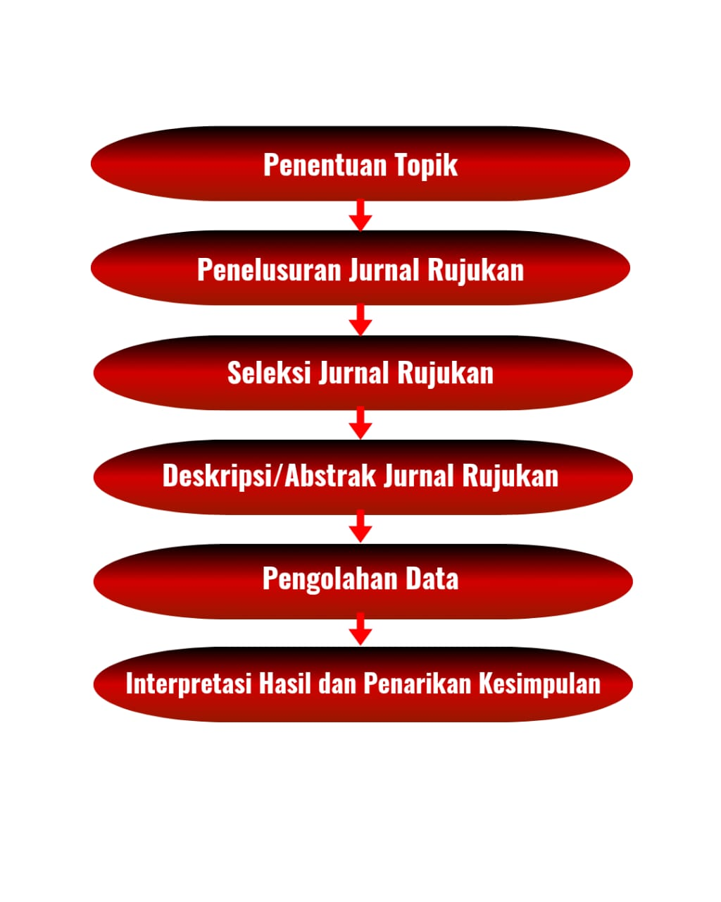

1. **LIST OF REVIEWED ARTICLES**

| **No** | **Tahun** | **Judul Artikel** | **Jenis Publikasi** | **Volume/Nomor** | **Penulis** | **Nama Jurnal/Instansi** |
| --- | --- | --- | --- | --- | --- | --- |
| 1 | 2022 | Analisa dan Perancangan Aplikasi Pembelajaran Bahasa Inggris Dasar Berbasis Android | Artikel Ilmiah | Vol. 2 No. 2 | M. Fahmi, S. R. Andriyani | Jurnal Syntax Idea |
| 2 | 2021 | Analisis Macam-Macam Metode Pembelajaran Bahasa Inggris | Artikel Ilmiah | Vol. 6 No. 2 | Ahmad Farid | Jurnal LINGUA |
| 3 | 2022 | Aplikasi TikTok sebagai Media Pembelajaran Bahasa Inggris di Indonesia | Artikel Ilmiah | Vol. 1 No. 2 | Miftahul Jannah | Jurnal Ilmiah Sosial Humaniora |
| 4 | 2023 | Efektivitas Penggunaan Teknologi AI dalam Pembelajaran Bahasa Inggris | Artikel Ilmiah | Vol. 3 No. 1 | Rizky Maulana | Jurnal EduTechno |
| 5 | 2023 | Pelatihan Penggunaan Aplikasi Canva sebagai Media Pembuatan Bahan Ajar | Prosiding/Pengabdian Masyarakat | - | Ervina Nur Aini | LPPM Universitas KH. A. Wahab Hasbullah |
| 6 | 2022 | Pemanfaatan H5P dalam Pengembangan Media Pembelajaran Bahasa Online Interaktif | Artikel Ilmiah | Vol. 3 No. 1 | Intan Puspita Sari | Jurnal Media Edukasi |
| 7 | 2010 | Pembuatan Aplikasi Pembelajaran Bahasa Inggris pada Handphone dengan J2ME | Tugas Akhir/Skripsi | - | Yuli Prasetya | STMIK AMIKOM Yogyakarta |
| 8 | 2020 | Penelitian Tindakan Kelas Pembelajaran Bahasa Inggris | Laporan PTK | - | Lusi Indah Sari | SDN Jatisari II Malang |
| 9 | 2021 | Pengaruh Metode Pembelajaran Berbasis Proyek pada Kemampuan Berbicara | Artikel Ilmiah | Vol. 4 No. 1 | Nurul Zahro | Jurnal Pendidikan Bahasa Inggris |
| 10 | 2022 | Pengembangan Media Pembelajaran Bahasa Inggris Berupa Flashcard Bergambar | Artikel Ilmiah | Vol. 2 No. 1 | Anisa Rahmawati | Jurnal Pendidikan Dasar |

### ****RESULTS AND DISCUSSION****

1. **Analysis and Design of a Basic English Learning Application Based on Android (2022)**  
   This article shows that using Android-based applications can enhance student engagement and motivation in learning basic English. The interactive system design makes it easier for students to access materials anytime, offering flexibility in the learning process. The discussion emphasizes that application development should consider user needs and content aligned with the curriculum.
2. **Analysis of Various English Learning Methods (2021)**  
   The study identifies several teaching methods such as Grammar Translation Method, Direct Method, and Communicative Language Teaching. The discussion reveals that method selection should be aligned with learning objectives and student characteristics to achieve optimal outcomes.
3. **TikTok Application as a Medium for English Language Learning in Indonesia (2022)**  
   This article finds that TikTok can be effectively used as a learning tool for English, especially to improve speaking skills and vocabulary. The discussion highlights the importance of teacher creativity in utilizing social media as a fun and relevant learning platform for the younger generation.
4. **The Effectiveness of Using AI Technology in English Language Learning (2023)**  
   The use of Artificial Intelligence (AI) technology such as chatbots and adaptive learning has proven to increase the effectiveness of English teaching. The article discusses how AI can provide instant feedback and a personalized learning experience, although teacher supervision is still necessary to ensure balanced learning.
5. **Training on Using Canva Application as a Medium for Creating Teaching Materials (2023)**  
   The training shows that teachers can easily create engaging visual teaching materials using Canva. The results show improved teacher creativity in preparing instructional content. The discussion emphasizes the need for continuous training to help teachers keep up with educational technology advancements.
6. **Utilization of H5P in Developing Interactive Online English Learning Media (2022)**  
   The use of H5P results in interactive learning media that increases student engagement in online learning. The discussion suggests that integrating interactive elements such as quizzes, drag-and-drop features, and interactive videos greatly aids material comprehension and prevents monotonous learning.
7. **Development of an English Learning Application for Mobile Phones Using J2ME (2010)**  
   This J2ME-based application enabled English learning on basic mobile phones. Although outdated by today’s standards, the article shows that mobile learning was relevant even in the early 2010s and served as a foundation for modern application development.
8. **Classroom Action Research on English Language Learning (2020)**  
   This classroom action research shows an improvement in student learning outcomes after implementing active learning approaches in English teaching. The discussion emphasizes the importance of teacher reflection on teaching practices and adapting strategies based on classroom conditions.
9. **The Effect of Project-Based Learning Method on Speaking Skills (2021)**  
   The Project-Based Learning method significantly improves students’ speaking abilities. The article highlights how this approach allows students to practice in real-life contexts, boosting their confidence and communication skills.
10. **Development of English Learning Media in the Form of Illustrated Flashcards (2022)**  
    Illustrated flashcards effectively enhance vocabulary mastery among elementary school students. The article emphasizes that visual media are highly effective for beginner learners, especially in boosting memory retention and classroom engagement.

**CONCLUSION**

The analysis of the ten reviewed articles highlights the dynamic development and innovation in English language learning, particularly in Indonesia. It can be concluded that the integration of technology—such as Android-based applications, AI, H5P, and Canva—has significantly enhanced the accessibility, interactivity, and effectiveness of English language education across different learning levels. These technologies not only support self-paced learning but also foster creativity among both students and educators.

Furthermore, various teaching methods, including project-based learning and the use of visual media like illustrated flashcards, have proven to improve specific language skills, especially speaking and vocabulary. Social media platforms like TikTok also show great potential in engaging younger learners by aligning with their interests and communication habits.

Despite the positive outcomes, the studies underline the need for continuous teacher training and appropriate curriculum alignment to ensure that technological tools and methods are effectively applied. Classroom-based research further confirms that reflective teaching practices and context-aware strategies are key to improving learning outcomes.

Overall, the synergy between pedagogical strategies and digital tools is essential in creating a more engaging, inclusive, and effective English language learning environment. Future educational programs should focus on sustainable integration of these innovations while maintaining the human aspect of teaching through teacher-student interaction.

**REFERENCES :**

The following is a list of references compiled based on the reviewed articles:

1. Fahmi, M., & Andriyani, S. R. (2022). Analisa dan perancangan aplikasi pembelajaran Bahasa Inggris dasar berbasis Android. Jurnal Syntax Idea, 2(2), 110–118.
2. Farid, A. (2021). Analisis macam-macam metode pembelajaran Bahasa Inggris. Jurnal LINGUA, 6(2), 45–53.
3. Jannah, M. (2022). Aplikasi TikTok sebagai media pembelajaran Bahasa Inggris di Indonesia. Jurnal Ilmiah Sosial Humaniora, 1(2), 66–73.
4. Maulana, R. (2023). Efektivitas penggunaan teknologi AI dalam pembelajaran Bahasa Inggris. Jurnal EduTechno, 3(1), 12–20.
5. Aini, E. N. (2023). Pelatihan penggunaan aplikasi Canva sebagai media pembuatan bahan ajar dalam pembelajaran Bahasa Inggris. Laporan Pengabdian Masyarakat, LPPM Universitas KH. A. Wahab Hasbullah.
6. Sari, I. P. (2022). Pemanfaatan H5P dalam pengembangan media pembelajaran Bahasa Inggris online interaktif. Jurnal Media Edukasi, 3(1), 33–40.
7. Prasetya, Y. (2010). Pembuatan aplikasi pembelajaran Bahasa Inggris pada handphone dengan J2ME (Skripsi). STMIK AMIKOM Yogyakarta.
8. Sari, L. I. (2020). Penelitian tindakan kelas pembelajaran Bahasa Inggris untuk meningkatkan hasil belajar siswa. Laporan PTK, SDN Jatisari II Malang.
9. Zahro, N. (2021). Pengaruh metode pembelajaran berbasis proyek pada kemampuan berbicara Bahasa Inggris siswa. Jurnal Pendidikan Bahasa Inggris, 4(1), 21–29.
10. Rahmawati, A. (2022). Pengembangan media pembelajaran Bahasa Inggris berupa flashcard bergambar pada tingkat sekolah dasar. Jurnal Pendidikan Dasar, 2(1), 50–58.